SIMATS ENGINEERING

ASSESSMENT TOOL 2: Concept Mapping

COURSE NAME: | Cloud Computing and  Big Data Analytics | COURSE CODE: | CSA15

COURSE OUTCOME COVERED
CO1: Apply cloud computing technologies including hardware-software evolution, virtualization, web services, and service models to develop cloud-based solutions. (BL2)
Assessment Tool Weightage: 20%

Dave's Taxonomy: Imitation (Level 1)  Question Count: 4 | Total Marks: 20

Code of Conduct
I C.NIKITHA(1925260079) (Name / Reg No) certify that this submission is my original work and that I have adhered to the guidelines specified for this assessment.
I understand that any violation of academic integrity rules will result in disciplinary action. Signature of the student: NIKITHA

Assessment Tasks Concept Mapping Tasks
Create concept maps for the following tasks. Each map must show key nodes, link labels, and a logical hierarchy.
- Concept Map 1: Cloud Computing Fundamentals. Include definition, characteristics, benefits, and limitations.
- Concept Map 2: Evolution of Cloud Computing. Connect hardware evolution, internet software evolution, distributed systems, and service delivery.
- Concept Map 3: Service Models. Map IaaS, PaaS, SaaS, and XaaS with provider responsibilities and user responsibilities.
- Concept Map 4: Virtualization and Web Services as Enablers of Cloud. Show how these two concepts support cloud deployment and scalability.

Expected concept nodes:
  - Elasticity, scalability, resource pooling, on-demand access, measured service
  - Virtual machine, hypervisor, abstraction, API, SOAP, REST, provider, consumer
  - Infrastructure layer, platform layer, application layer, shared responsibility

Concept Mapping Rubric
Criteria | Weightage | Level 4 -  Exemplary | Level 3 -  Proficient | Level 2 -  Developing | Level 1 -  Beginning
Concept Identification | 25% | All major concepts are accurately identified | Most concepts are identified correctly | Limited concepts are identified | Essential concepts are missing

Relationship Mapping | 25% | Links between concepts are accurate and  meaningful | Most links are correct | Some links are weak or unclear | Relationships are mostly incorrect
Hierarchy and Organization | 20% | Excellent structure with clear hierarchy | Mostly organized with minor issues | Basic structure with weak hierarchy | No logical organization
Technical Relevance | 20% | Map strongly reflects cloud course content | Mostly aligned to topic | Partially aligned to topic | Weak alignment to topic
Visual Clarity | 10% | Neat, readable, and easy to interpret | Generally readable | Somewhat cluttered | Poorly presented

1)
- Concept Map 4: Virtualization and Web Services as Enablers of Cloud. Show how these two concepts support cloud deployment and scalability.
- Concept Map 4: Virtualization and Web Services as Enablers of Cloud. Show how these two concepts support cloud deployment and scalability.
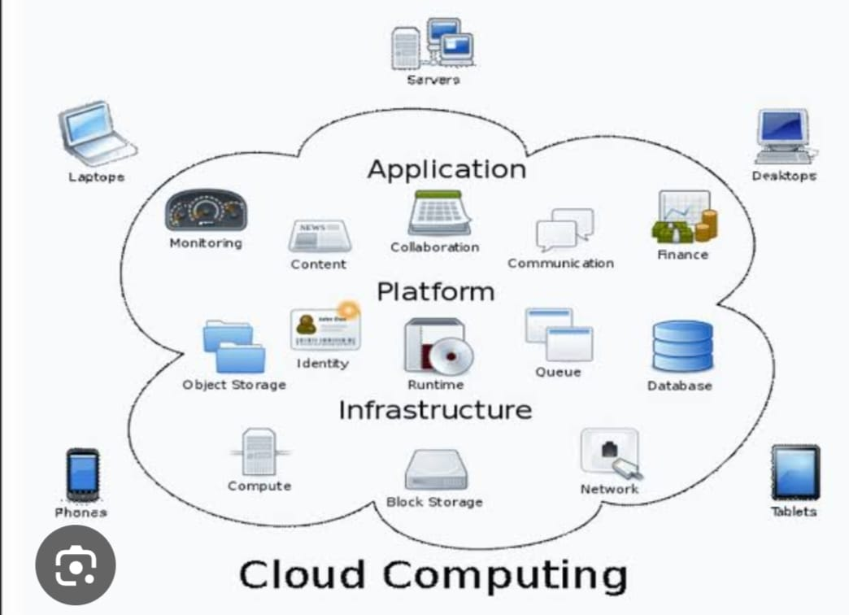

Accessibility:
Business applications
Data storage and backup
Communication and video conferencing
6. Conclusion
Cloud computing is an important technology that provides applications, platforms Data and applications can be accessed from different locations using the internet.
Storage: Stores large amounts of data online.
Backup and recovery: Helps protect data and restore it after failures.
Collaboration: Multiple users can work together on shared files and applications.
5. Applications of Cloud Computing
Education and online learning
Banking and finance
Healthcare
, and infrastructure through the internet. It makes computing easier, more flexible, and cost-effective for individuals and organizations.
2) 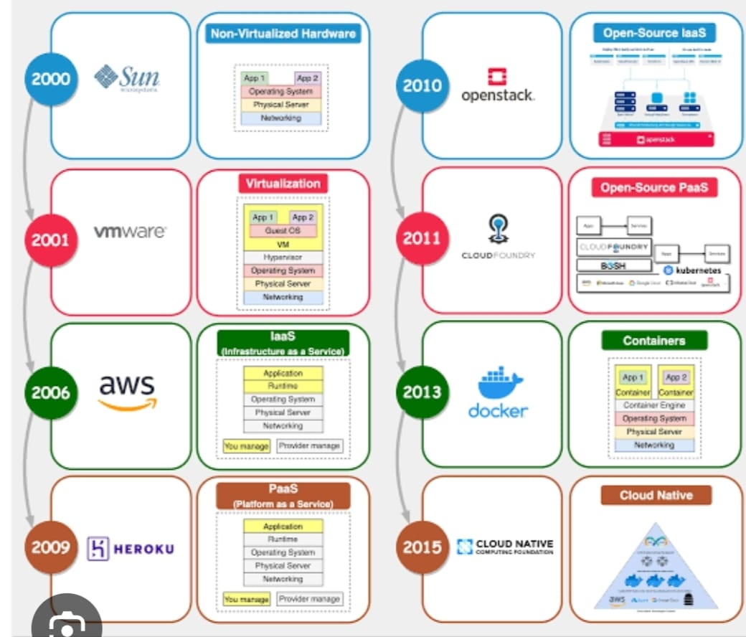
8. 2015 – Cloud-Native Computing
Cloud-native technologies support scalable and flexible 6. 2011 – Open-Source PaaS
Cloud Foundry helped developers deploy and manage applications on cloud platforms with less infrastructure management.
7. 2013 – Containers
Docker popularized container technology. Containers package applications and their dependencies so they can run consistently in different environments.
applications. They commonly use containers, microservices, automation, and orchestration tools such as Kubernetes.
3)
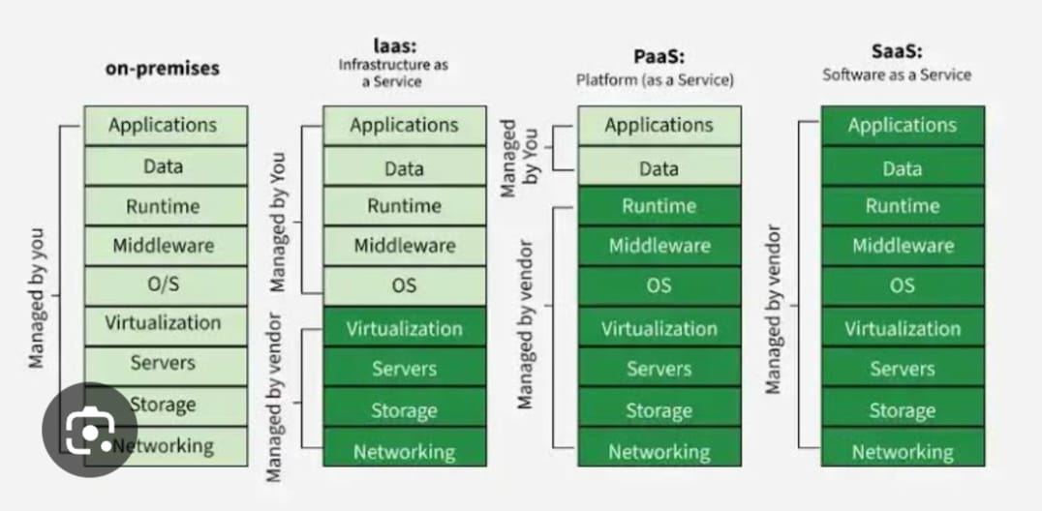

Example: Amazon EC2 and Microsoft Azure Virtual Machines.
3. PaaS (
to develop, test, and deploy applications.
The cloud provider Platform as a Service)
PaaS provides a platform manages servers, storage, networking, virtualization, operating systems, and middleware.
The user mainly manages applications and data.
Example: Google App Engine and Heroku.
4. SaaS (Software as a Service)
SaaS provides ready-to-use software through the internet.
The cloud provider manages the entire infrastructure and software platform.
Users simply access and use the application.
Example: Gmail, Google Docs, and Microsoft 365.
4) 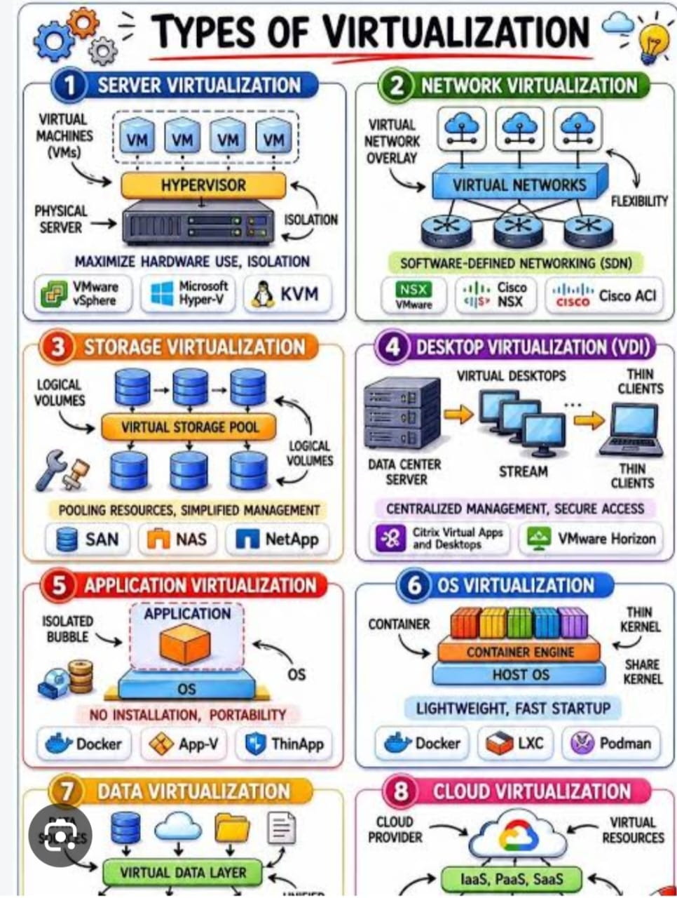

It creates virtual computing resources such as servers, storage, and networks.
These resources are provided to users over the internet.
It offers scalability, flexibility, and efficient resource utilization.
Examples: Google Cloud, AWS, Microsoft Azure.
Advantages of Virtualization
Reduces hardware and maintenance costs.
Improves resource utilization.
Provides flexibility and scalability.
Simplifies resource management.
Supports isolation and better security when properly configured.
Conclusion
Virtualization is an important technology in cloud computing. It helps organizations share resources efficiently, reduce costs, and provide computing services whenever needed. Different types of virtualization support servers, networks, storage, desktops, applications, operating systems, data, and cloud resources.

